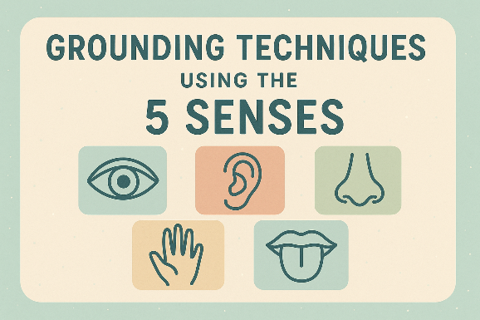

5 Senses Grounding
Purpose: A short, portable grounding exercise that uses all five senses to bring attention back to the present moment and reduce overwhelm.
How to use: Find a comfortable seated or standing position. If safe, keep your feet on the ground. Breathe slowly and naturally throughout. Aim for 2–5 minutes; you can do a shorter or longer version as needed.

Steps (clear, step-by-step)
- Prepare (30 seconds)
  - Take 3 slow, deep breaths: inhale for 4, hold 1, exhale for 6. Notice how your body feels.
- Sight - 5 things you can see
  - Slowly look around and name 5 things out loud (or silently) you can see. Try to pick specific details (e.g., “striped mug,” “green leaf,” “sun on the wall”).
- Touch - 4 things you can feel
  - Focus on 4 different physical sensations. Touch an object (fabric, table) or notice sensations on your body (feet on floor, clothing against skin). Describe them: texture, temperature, pressure.
- Hearing - 3 things you can hear
  - Close your eyes if that helps. Identify 3 sounds, near or far (e.g., clock ticking, distant traffic, breathing). Notice pitch, rhythm, and how the sounds move.
- Smell - 2 things you can smell
  - Take two gentle sniffs. If you don’t notice smells right away, bring an item (coffee, soap, outdoors air) or simply notice subtle scents (fabric, the room). Name two.
- Taste - 1 thing you can taste
  - Notice the current taste in your mouth. If nothing is there, take one small sip of water, a mint, or a piece of fruit and focus on its flavor.
- Anchor with breath (30 seconds)
  - Finish with 3 slow breaths, paying attention to the rise and fall of your chest or the feeling of air at your nostrils. Notice any shift in tension or clarity.

Tips & Variations
- Shorter: Do one quick pass (1 sight, 1 touch, 1 sound, 1 smell, 1 taste) if you have only 30 seconds.
- Longer: Spend 30-60 seconds exploring each sense with more detail for deeper grounding.
- Accessible: If a sense is limited (e.g., smell), substitute another sense or use a memory (recall a smell you like) rather than forcing it.
- For children: Turn it into a game ("I spy 5 things…") and use playful language.

When to use
- During panic, anxiety, dissociation, racing thoughts, or whenever you want to return to the present.

Safety note
- If this brings up strong emotions, pause and use a simpler self-soothing technique (slow breathing, safe person contact) or seek support from a counsellor or trusted person.

